WEDE5020 – Web Development Introduction
Website Project Proposal
DriveHub Motors
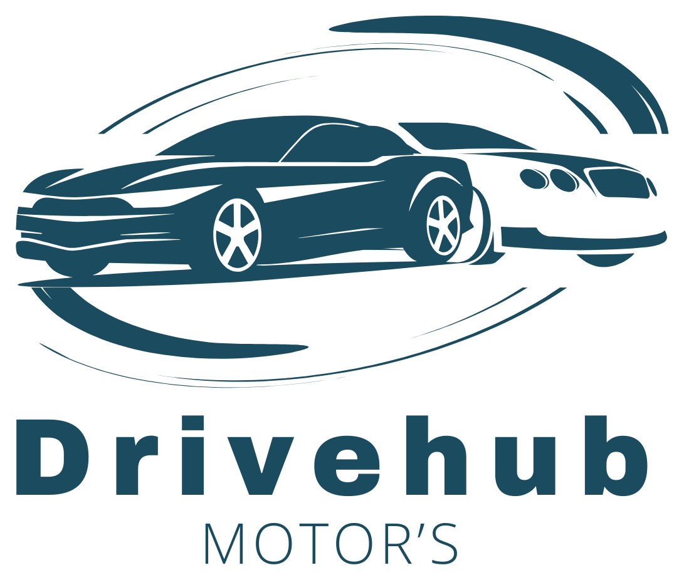
Prepared by: Ntatiso [Surname]
Student Number: ST10513686
Group: N/A
Date: August 2026

Table of Contents

1. Organisation Overview

Name
DriveHub Motors

Brief History
DriveHub Motors is a newly established Braamfontein dealership that curates premium and performance vehicles through trusted dealer partners, beginning with Pharoah Auto Investments in Sandton.

Mission
To provide honest advice, fair pricing, and dependable vehicles, backed by a service team that treats every customer like family.

Vision
To become Johannesburg's most trusted name in curated vehicle sales, known for transparency, quality, and service.

Target Audience
Students, young professionals, and families across Braamfontein and Johannesburg seeking premium SUVs, performance cars, or family vehicles.

2. Website Goals and Objectives
The website aims to showcase current inventory, build trust and brand credibility, and generate qualified enquiries and test-drive bookings.

Key Performance Indicators (KPIs)
- Monthly unique visitors
- Contact form submissions per month
- Average session duration
- Click-through rate: Home to Products and Services
- Enquiry-to-showroom-visit conversion rate

3. Current Website Analysis
DriveHub Motors has no website of its own yet, so this analysis instead reviews pharoahgroup.com, the site of Pharoah Group, our vehicle-sourcing partner in Bryanston, Sandton (Pharoah Group, 2026).

Strengths
The site opens with a confident, lifestyle-driven brand statement (“More Than Cars, It's Culture”) rather than a generic listings page, and it segments its 170+ vehicle inventory clearly by price tier and by brand. Calls to action – Book a Viewing, Apply for Finance, Sell Your Car – are prominent throughout.

Weaknesses
Its “News” section currently displays unrelated third-party promotional content (online casino and betting articles) instead of dealership news, suggesting an unmoderated or compromised content feed. Navigation also leans heavily towards commerce, leaving little room for the informational content (FAQs, buying guides) that builds trust with first-time buyers.

Takeaways for DriveHub Motors
Adopt the same clear, category-based segmentation and confident calls to action (already reflected in Section 4), but keep the News section limited to first-party, manually authored content, and treat the security measures in Section 6 as a priority from launch rather than an afterthought.

4. Proposed Website Features and Functionality
The website has seven linked pages, sharing a consistent header, horizontal navigation, and footer:
- Home – a hero image, a “Why Choose DriveHub Motors” section stating the value proposition, and a two-vehicle “Featured Vehicles” showcase with captioned photography
- About Us – the company story explaining the curated dealer-partner sourcing model, a mission statement, and a bulleted list of core values
- Products and Services – an interactive, JavaScript-filterable vehicle inventory grouped into three categories (SUVs and Off-Roaders, Sports and Performance, Family and Premium), rendered dynamically from a central vehicle list, alongside a static list of dealership services
- Gallery – a responsive photo grid of vehicle interiors and exteriors that opens into a JavaScript lightbox for a larger, captioned view
- News and Updates – dated article entries covering stock arrivals, partnerships, and promotions
- Contact Us – a full address and opening-hours table, a validated contact form with a message-type field, and an embedded interactive Leaflet map
- Enquire – a dedicated enquiry form capturing vehicle category and enquiry type (purchase, financing, trade-in, or test drive), which returns an on-page response with relevant cost or availability information

5. Design and User Experience

Colour Scheme
Deep Teal (#245264), taken from the DriveHub Motors logo, is the primary colour, paired with white and light grey backgrounds and a muted gold accent (#B8860B) for calls to action.

Typography
Montserrat (headings) paired with Open Sans (body text) – clean, modern, highly legible sans-serifs.

Layout and Design
A minimal, image-forward layout with horizontal navigation, a consistent header and footer, and generous white space.

User Experience Considerations
- Simple horizontal navigation on every page
- Prominent contact and test-drive calls to action
- Descriptive alt text for accessibility
- Mobile-first layout, to be implemented in Part 2

Wireframes
Low-fidelity wireframes for the Home page and a representative interior page are shown below.

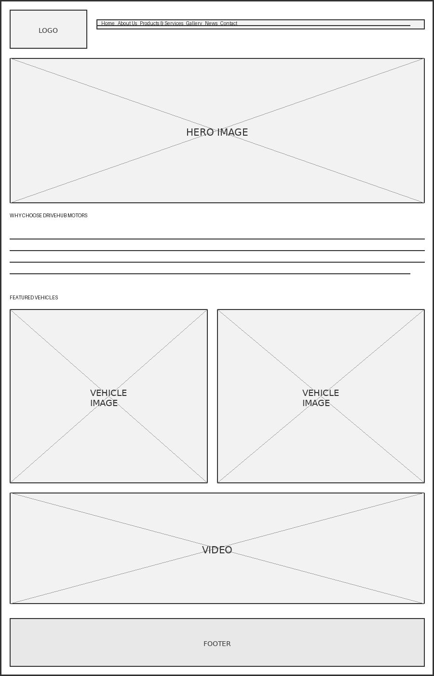
Figure 1: Low-fidelity wireframe – Home page

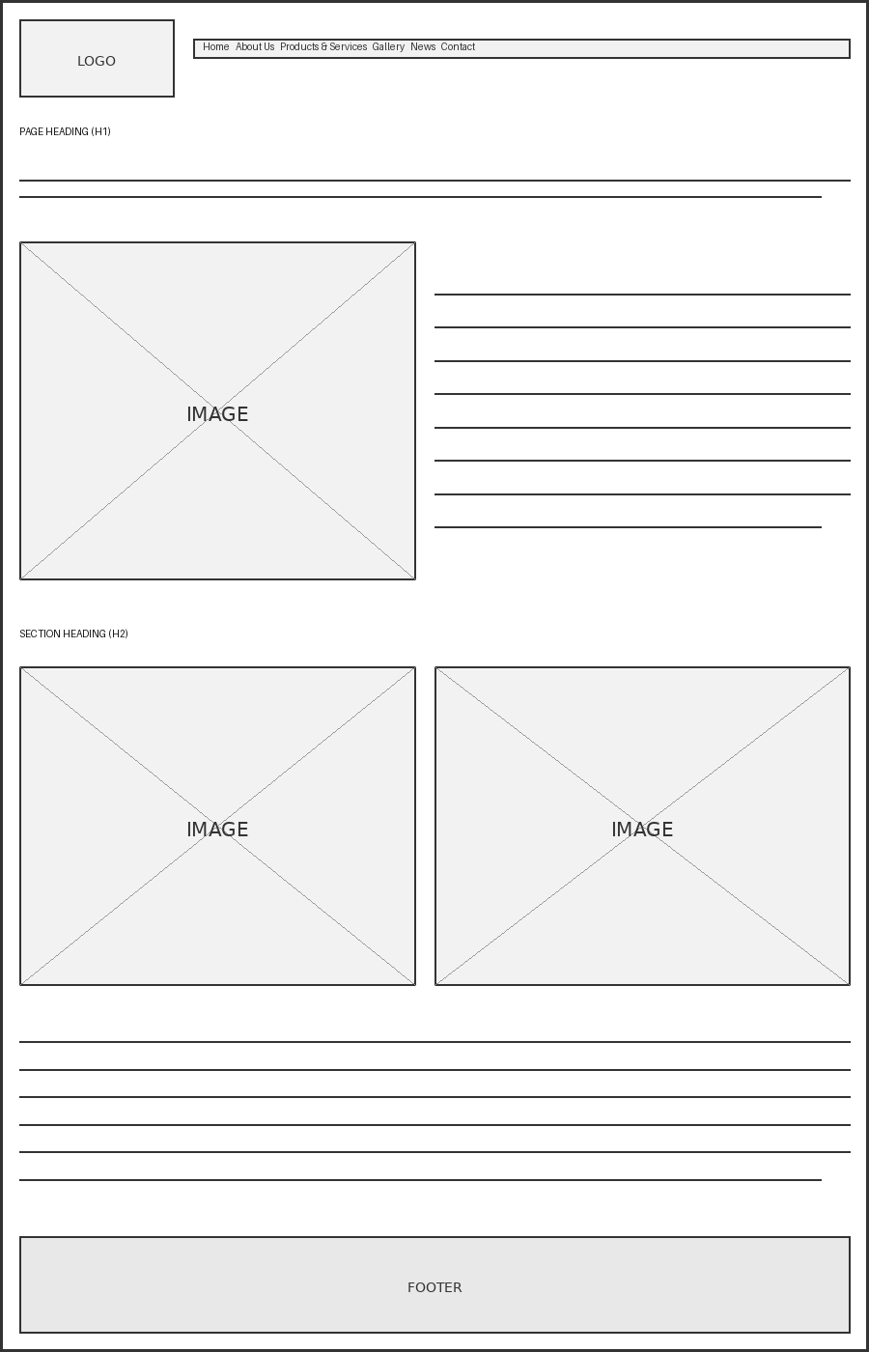
Figure 2: Low-fidelity wireframe – representative interior page

6. Technical Requirements
- Hosting: GitHub Pages – free static hosting integrated with the project's Git repository
- Domain: www.drivehubmotors.co.za, a South African .co.za domain
- Languages: HTML5 (Part 1), CSS3 (Part 2), and vanilla JavaScript (Part 3)

7. Timeline and Milestones
The timeline follows the three-part WEDE5020 POE structure; confirm exact dates against the official module calendar.
Milestone | Target Date
Part 1 – HTML structure and content | August 2026
Part 2 – CSS styling and responsive design | September 2026
Part 3 – JavaScript functionality | October 2026
Final testing, proofreading, and submission | October 2026

8. Budget
As a static, self-hosted project, running costs are minimal, based on current South African pricing.
Item | Estimated Cost
Domain registration (.co.za, annual) | R99 – R150
Hosting (GitHub Pages) | Free
SSL certificate | Free (included)
Vehicle photography | R0 (in-house)
Ongoing maintenance | Own time; no direct cost
Total estimated first-year cost | Approx. R99 – R150

9. References
GitHub, 2026. GitHub Pages Documentation. [online] Available at: <https://docs.github.com/pages> [Accessed 13 August 2026].
MyBroadband, 2025. Cheapest .CO.ZA domain prices. [online] Available at: <https://mybroadband.co.za/news/cloud-hosting/589029-cheapest-co-za-domain-prices.html> [Accessed 13 August 2026].
Google Fonts, 2026. Montserrat and Open Sans. [online] Available at: <https://fonts.google.com> [Accessed 13 August 2026].
Pharoah Group, 2026. Pharoah Group | Luxury & Supercar Dealer in Bryanston, Sandton. [online] Available at: <https://pharoahgroup.com> [Accessed 2 September 2026].

